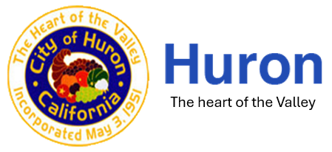
Part-Time Animal Control & Code Enforcement Officer
Job Announcement
The City of Huron is dedicated to providing efficient and effective quality municipal services that enhance the quality of life in a way that provides a financially viable, business-friendly and family-oriented community, promoting a full range of housing, business, and culture in a safe and attractive environment. The City of Huron is seeking a dedicated and versatile Animal Control & Code Enforcement Officer to enforce municipal codes, ordinances, and animal control regulations. This combined role ensures the health, safety, and welfare of the community and animals. The officer investigates complaints, performs field enforcement, educates the public, and promotes compliance in a professional and community-focused manner.

Key Responsibilities

Animal Control Responsibilities
- Enforce state and local animal control laws and ordinances
- Respond to calls involving stray, aggressive, injured, or deceased animals
- Capture, restrain, and transport animals safely and humanely
- Investigate animal bites, neglect, abuse, and nuisance complaints
- Issue citations and prepare reports for legal proceedings
- Assist with rabies control, quarantines, and animal licensing
- Educate the public on responsible pet ownership

Code Enforcement Responsibilities
- Enforce municipal codes, zoning regulations, and public safety ordinances
- Investigate property maintenance complaints, junk vehicles, overgrown vegetation, illegal signs, and nuisance violations
- Conduct property inspections and document violations with photographs and reports
- Issue notices of violation, citations, and coordinate compliance efforts
- Prepare cases for administrative hearings or court proceedings
- Collaborate with residents, businesses, city departments, and law enforcement

General Duties
- Maintain accurate records, logs, and reports using electronic systems
- Maintain vehicles, equipment, and related tools
- Participate in community education programs
- Perform other duties as assigned

Minimum Qualifications
- High school diploma or GED
- Valid California Driver’s License
- Ability to obtain Animal Control Officer certification and/or Code Enforcement certification within a specified timeframe
- Ability to pass background check
- Strong interpersonal, conflict resolution, and public communication skills

Preferred Qualifications
- Associate’s or Bachelor’s degree in public administration, criminal justice, animal science, or related field
- Prior experience in animal control, code enforcement, planning, or law enforcement
- Knowledge of municipal codes, zoning, public safety regulations, and animal handling
- Bilingual (English/Spanish)

Physical & Working Conditions
- Outdoor fieldwork in varying weather conditions
- Frequent walking, bending, climbing, and lifting (up to 50–75 lbs)
- Exposure to animals, construction sites, overgrown or unsafe properties, and public hazards
- Evening, weekend, holiday, and on-call required

Position offers a starting salary between $17-$20 per hour and California Paid Sick Leave. To apply, please submit a resume, cover letter, and job application to huron@huronca.gov by Friday, June 12, 2026.

The City of Huron is an Equal Opportunity Employer

